Задания для самостоятельной работы по английскому языку на 05.03.2019
Учитель Чайникова В.Г.
3-А: учебник у. 1 с. 62; су у. 7-8 с. 54
10-А: учебник у. 8-11 с. 51, у. 5 с. 171; работа над проектом «My school»
9-А: написать письмо:
You have received a letter from your English-speaking pen friend, Andrew.
…My laptop is broken and will be at the repair centre for a week, cause it's holiday time now. This made me realise how dependent I am on my computer. I know it has good and bad sides, but people can’t do without computers nowadays…
…How much time do you usually spend on your computer? What do you use it for? People of what professions need excellent computer skills, in your view?…
Write him a letter and answer his 3 questions.
Write 100–120 words. Remember the rules of letter writing.

11-А, 11-В: подготовить чтение текста (1), выучить описание картинки наиз. (2)

- Чтение текста.
Half the human beings who have ever died, perhaps as many as 45 billion people, have been killed by female mosquitoes. Mosquitoes carry more than a hundred potentially fatal diseases including malaria, yellow fever and elephantiasis. Even today, they kill one person every twelve seconds. Amazingly, nobody had any idea that mosquitoes were dangerous until the end of the nineteenth century. In 1877, the British doctor Sir Patrick Manson proved that yellow fever was caused by mosquito bites.
Seventeen years later it occurred to him that malaria might also be caused by mosquitoes. He encouraged his pupil Ronald Ross to test the hypothesis. Ross was the first person to show how female mosquitoes transmit the parasite. Manson went one better. To show that the theory worked for humans, he infected his own son – using mosquitoes carried in the diplomatic bag from Rome.

- Описание картинки (наиз.)
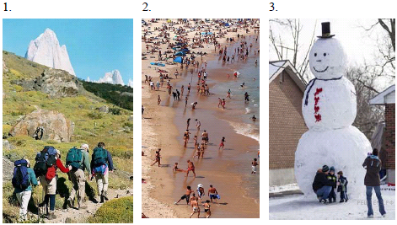
I’ve chosen photo number 3. I would like to tell you more about this picture. In my family we have a tradition to spend winter holidays abroad. That is why we’d decided to rent a house in a foreign country and spend 2 unforgettable weeks together. We went there at the end of December. Such trips make me forget about daily routine which eventually becomes highly irritating. I took the picture when we had just come to the village where the rented house was situated. The village is very old. In the background of the photo you can see a giant snowman. It was made by the locals and they seemed to be very proud of that. My mom is making picture of my dad and two little brothers. I keep the photo in my album, because I am fond of this giant snowman. I think that it's a very nice shot. I showed the picture to you because I guess you had never seen anything like it before. I hope that we will return to that place next year together.

